TAC OFFICER K. HENSON BLEA SESSION 616 TAC OFFICER K. PITTS

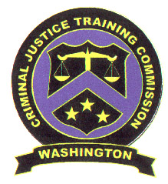
State of Washington

WashinGton State Criminal Justice Training Commission
Criminal Justice Training Center – 19010 1st ave s. – BURIEN, Washington 98148 (206) 835-7300
memorandum

DATE: August 13, 2007

TO: BLEA Class 616

FROM: TAC Officer Henson

SUBJECT: Receipt of BLEA Anti-Harassment Policy

By my signature affixed to this document, I acknowledge receipt of the Basic Law Enforcement Academy Anti-Harassment Policy, as set forth by the Washington State Criminal Justice Training Commission.

I certify that I have read and comprehend the Basic Law Enforcement Academy Anti-Harassment Policy contained herein and I understand that my failure to abide by the policy could result in disciplinary action against me and/or my termination from the Basic Law Enforcement Academy.

Name (print): _____________________________________________

Signature: ________________________________________________

Agency: _________________________________________________

Date/Time Signed: _________________________________________

